KOVA BIOS- Seed Funding Proposal
Business Canvas
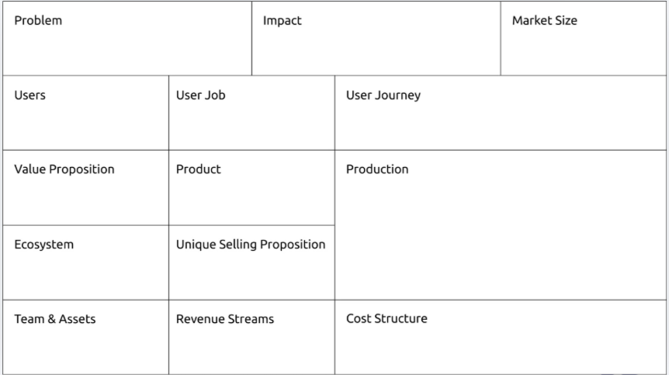

Problem
As Your User Group Job of User, they have a Problem. This problem affects Market Size.
Other Data on the Problem.
Solution
Our solution is Your Product/Service. It helps Your User Group Job of User more Value Proposition.
Scalability/Innovation
Other ecosystem actors offer..., but our offering will be more Unique Selling Proposition because Innovations.
So, we could grow to reach Geographic Market.

Business Model
We’ll sell each Unit of Product of Your Product/Service for Price (in $)
Each Unit of Product will cost us Total Unit Cost (in $) to make, the cost breakdown being:
- Xxx - $1
- Xxx - $0.5
- …
Our monthly operations costs will total Monthly Operations Costs (in $), from:
- Salaries:
- Rent:
- …
To get started, we’ll also have capital expenditure of Total CapEx (in $) on:
- Legal Registration -
- Machine-
- …
Social & Environmental Impact
Wider benefits of our solution’s use will be Impacts. We’ll measure these with:
- Key Performance Indicator 1
- Key Performance Indicator 2
- …
Market Validation / Risk Mitigation
The biggest assumptions behind our venture model have been validated with the following 3+ prototyping tests:
- Describe the riskiest assumption;
  - Describe the test and the results.
- Describe the 2nd most risky assumption;
  - Describe the test and the results.
- Describe the 3rd most risky assumption;
  - Describe the test and the results.
- …

Team
- Name, Email, Phone
  - Role & Qualifications for Role
- Name, Email, Phone
  - Role & Qualifications for Role
- …

Budget for Funding
We’ll use the $X,000 to cover the Total CapEx (in $) initial capital expenditure, and make No. Units Made Unit of Product of Your Product/Service and cover No. Months Funded months of operations costs. The breakdown of the budget is:
Item Description | Cost | No. Units | Amount
Unit Costs | Total Unit Cost (in $) | No. Units Made
Operations Costs | Monthly Operations Costs (in $) | No. Months Funded
Capital Expenditure | Total CapEx (in $) | 1
TOTAL

Goals
With $X,000, we’ll track performance against the following milestones/targets:
- Registration - We’ll register a company and open a bank account by [month].
- Product Design -
- Production & Partnerships -
- Sales - We’ll sell No. Units Made Unit of Product of Your Product/Service in No. Months Funded months, generating $xxxx in revenue.
- …

